MOBILE BOX OFFICE TUTORIAL

Setting up:
As soon as you get to work your shift (1hr before the concert starts) set up the movable Box Office. Make sure to ask the Head Usher and/or House manager for the following to set up the Movable Box Office:
- Black Table Cloth
- Tablet (s)
- Will Call & Box Office signs
- Will Call reservations
- Pre-printed tickets

Opening the Concert on the app:
- Go to the BOX OFFICE app
- Make sure to select the correct PERFORMANCE DATE
- For FEE HANDLING select “Let me choose when to waive fees”
- For DELIVERY OPTIONS select “Prompt me to print tickets after each other”
- Select the Concert for that specific time. (Ex. NEC Philharmonia – Wednesday, February 13, 2019 at 7:30pm) Sometimes we will have multiple concerts on the same day, so make sure you select the correct one.
- Select START
- Select again the specific concert for that day & time.
- You are now ready to issue tickets to patrons that come to the Movable Box Office!
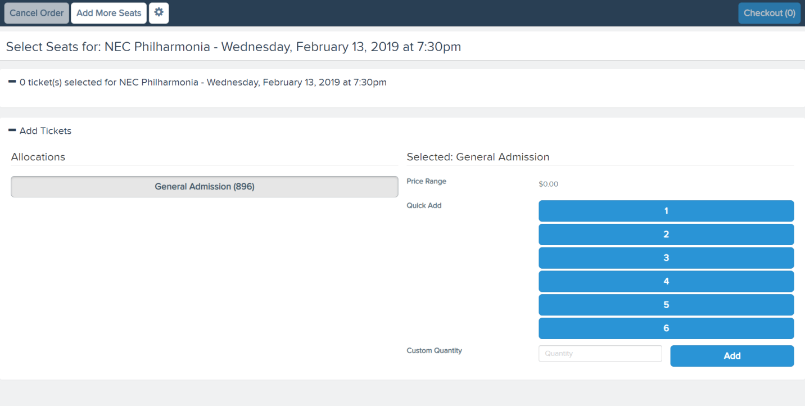

Issuing tickets:
- When a patron walks up to the table ask if they are picking up will call tickets or if they need to get tickets.
- If they are looking to get tickets select the amount of tickets they need on the left corner and then select CHECKOUT in the upper right hand corner.
- Make sure to ask the patron’s First and Last Names and type them in the CONTACT LOOKUP tab under BUYER INFO.
- If the patron’s name appears in the list select it.
- If the patron’s name does not appear in the list just hit the Tab key twice and this will automatically populate the First and Last Name tabs.
- Make sure to ask for their EMAIL ADDRESS if the patron is not in our data base! Check the Usher talking points sheet to know what to say in case patrons ask why we collect the information. They can always Opt Out of it.
- Finally, select SUBMIT ORDER in the upper right hand corner and hand the patron the tickets they need from the stack of pre-printed tickets.

